

Step-by-Step Guide: Deploying SSTP Remote Access
Microsoft Corporation
Published: December 2007
Abstract
Secure Socket Tunneling Protocol (SSTP) is a new form of VPN tunnel with features that allow traffic to pass through firewalls that block PPTP and L2TP/IPsec traffic. SSTP provides a mechanism to encapsulate PPP traffic over the SSL channel of the HTTPS protocol. The use of PPP allows support for strong authentication methods such as EAP-TLS. The use of HTTPS means traffic will flow through TCP port 443, a port commonly used for Web access. Secure Sockets Layer (SSL) provides transport-level security with enhanced key negotiation, encryption, and integrity checking.
This paper provides detailed information about how you can use three computers to create a test lab with which to configure and test virtual private network (VPN) remote access with Windows Server® 2008 and Windows Vista® with Service Pack 1 (SP1). These instructions are designed to take you step by step through the configuration required for a Secure Socket Tunneling Protocol (SSTP) connection.

Copyright Information
This document supports a preliminary release of a software product that may be changed substantially prior to final commercial release, and is the confidential and proprietary information of Microsoft Corporation. It is disclosed pursuant to a non-disclosure agreement between the recipient and Microsoft. This document is provided for informational purposes only and Microsoft makes no warranties, either express or implied, in this document. Information in this document, including URL and other Internet Web site references, is subject to change without notice. The entire risk of the use or the results from the use of this document remains with the user. Unless otherwise noted, the example companies, organizations, products, domain names, e-mail addresses, logos, people, places, and events depicted herein are fictitious, and no association with any real company, organization, product, domain name, e-mail address, logo, person, place, or event is intended or should be inferred. Complying with all applicable copyright laws is the responsibility of the user. Without limiting the rights under copyright, no part of this document may be reproduced, stored in or introduced into a retrieval system, or transmitted in any form or by any means (electronic, mechanical, photocopying, recording, or otherwise), or for any purpose, without the express written permission of Microsoft Corporation.

Microsoft may have patents, patent applications, trademarks, copyrights, or other intellectual property rights covering subject matter in this document. Except as expressly provided in any written license agreement from Microsoft, the furnishing of this document does not give you any license to these patents, trademarks, copyrights, or other intellectual property.

© 2007 Microsoft Corporation. All rights reserved.

Microsoft, MS-DOS, Windows, Windows NT, and Windows Server are either registered trademarks or trademarks of Microsoft Corporation in the United States and/or other countries.

All other trademarks are property of their respective owners.

Contents
Step-by-Step Guide: Deploying SSTP Remote Access 5
Secure Socket Tunneling Protocol 5
Setting up the test lab for SSTP remote access VPN connections 7
Configuring DC1 8
Configuring VPN1 12
Configuring CLIENT1 26
Simulating a PPTP-based connection failure 29
Configuring an SSTP-based connection 33
Additional Resources 38

Step-by-Step Guide: Deploying SSTP Remote Access
This guide provides detailed information about how you can use three computers to create a test lab with which to configure and test virtual private network (VPN) remote access with Windows Server® 2008 and Windows Vista® with Service Pack 1 (SP1). These instructions are designed to take you step by step through the configuration required for a Secure Socket Tunneling Protocol (SSTP) connection.
Note
The following instructions are for configuring a test lab by using a minimum number of computers and procedure steps. To minimize setup time and complexity, services were combined on the network servers rather than using individual computers to separate the services in a more secure manner. This configuration is designed to reflect neither best practices nor a desired or recommended configuration for a production network. The configuration, including IP addresses and all other configuration parameters, is designed to work only on a separate test lab network.

Consider using Virtual PC or Virtual Server
Microsoft Virtual PC or Virtual Server allows you to create the computer lab used in this document by using only one or two physical computers. After the virtual lab is configured, you can switch between the three virtual computers needed for this lab with the click of a button. For more information, see the following resources:
• Virtual PC 2007 Product Information (http://go.microsoft.com/fwlink/?LinkId=69217)
• Virtual Server Product Information (http://go.microsoft.com/fwlink/?LinkId=69220)
• Do More With Less: Exploring Virtual Server 2005 (http://go.microsoft.com/fwlink/?LinkId=69221)
• TechNet webcast: Virtual Server 2005 - Setting Up a Virtual Test and Development Environment—Level 200 (http://go.microsoft.com/fwlink/?LinkId=69222)

Secure Socket Tunneling Protocol
Secure Socket Tunneling Protocol (SSTP) is a new form of VPN tunnel with features that allow traffic to pass through firewalls that block PPTP and L2TP/IPsec traffic. SSTP provides a mechanism to encapsulate PPP traffic over the SSL channel of the HTTPS protocol. The use of PPP allows support for strong authentication methods such as EAP-TLS. The use of HTTPS means traffic will flow through TCP port 443, a port commonly used for Web access. Secure Sockets Layer (SSL) provides transport-level security with enhanced key negotiation, encryption, and integrity checking.

SSTP-based VPN connection process
The data flow for an SSTP-based VPN connection takes place as follows:
When a user on a computer running Windows Server 2008 or Windows Vista with SP1 initiates an SSTP-based VPN connection, the following occurs:
1. The SSTP client establishes a TCP connection with the SSTP server between a dynamically allocated TCP port on the SSTP client and TCP port 443 on the SSTP server.
2. The SSTP client sends an SSL Client-Hello message, indicating that the SSTP client wants to create an SSL session with the SSTP server.
3. The SSTP server sends its computer certificate to the SSTP client.
4. The SSTP client validates the computer certificate, determines the encryption method for the SSL session, generates an SSL session key and encrypts it with the public key of the SSTP server’s certificate, and then sends the encrypted form of the SSL session key to the SSTP server.
5. The SSTP server decrypts the encrypted SSL session key with the private key of its computer certificate. All future communication between the SSTP client and the SSTP server is encrypted with the negotiated encryption method and SSL session key.
6. The SSTP client sends an HTTP over SSL request message to the SSTP server.
7. The SSTP client negotiates an SSTP tunnel with the SSTP server.
8. The SSTP client negotiates a PPP connection with the SSTP server. This negotiation includes authenticating the user’s credentials with a PPP authentication method and configuring settings for Internet Protocol version 4 (IPv4) or Internet Protocol version 6 (IPv6) traffic.
9. The SSTP client begins sending IPv4 or IPv6 traffic over the PPP link.
Figure 1. Protocol level view of SSTP system architecture.
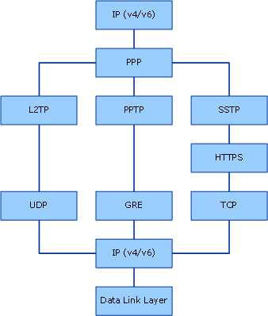

Setting up the test lab for SSTP remote access VPN connections
The infrastructure for the VPN test lab network consists of three computers, which perform the following services:
• A server computer running Windows Server 2008 named DC1 that acts as a domain controller, a Domain Name System (DNS) server, and a file server on a private (intranet) network.
• A server computer running Windows Server 2008 named VPN1 that is configured with Routing and Remote Access and acts as a VPN server. In addition, VPN1 is configured with Active Directory Certificate Services and Internet Information Services (IIS) to allow Web enrollment of the computer certificate required for an SSTP-based VPN connection. VPN1 has two network adapters installed.
• A client computer running Windows Vista with SP1 named CLIENT1 that acts as a VPN client on a public (Internet) network.
The following diagram shows the configuration of the VPN test lab.
Figure 2. Configuration of the SSTP connection test lab.
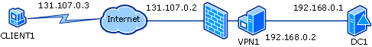

Configuring DC1
DC1 is a computer running Windows Server 2008 that provides the following services:
• A domain controller for the Contoso.com Active Directory® domain.
• A DNS server for the Contoso.com DNS domain.
• A file server.
The configuration of DC1 requires the following steps:
• Install the operating system.
• Configure TCP/IP.
• Install Active Directory and DNS.
• Create a user account with remote access permission.
• Create a shared folder and file.
The following sections explain these steps in detail.

Install the operating system
Install Windows Server 2008
1. On DC1, start your computer by using the Windows Server 2008 product disc.
2. Follow the instructions that appear on your screen. When prompted for a password, type P@ssword.

Configure TCP/IP
Configure TCP/IP properties so that DC1 has a static IP address of 192.168.0.1 with the subnet mask 255.255.255.0 and a default gateway of 192.168.0.2.
Configure TCP/IP properties
1. On DC1, in the Initial Configuration Tasks window, under Provide Computer Information, click Configure networking.
Note
If the Initial Configuration Tasks window is not already open, you can open it by clicking Start, clicking Run, typing oobe in the text box, and then clicking OK.
Figure 3. Initial Configuration Tasks window.
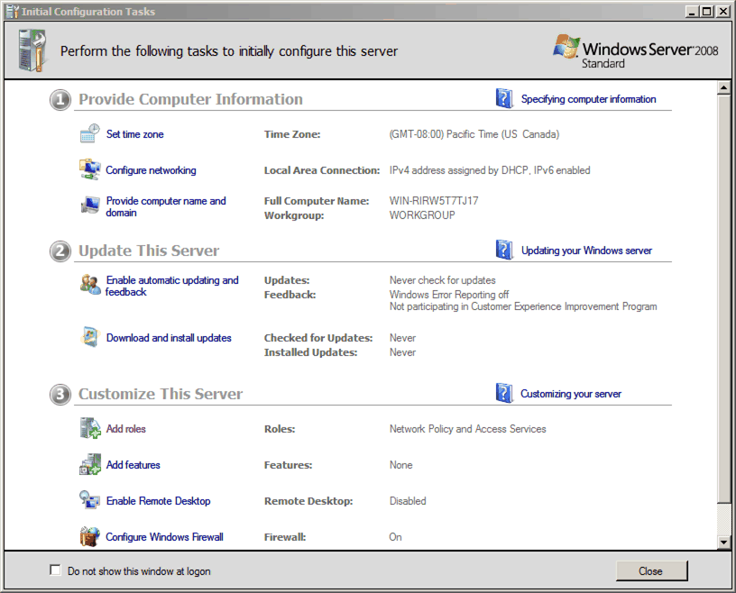

2. In the Network Connections window, right-click Local Area Connection, and then click Properties.
3. On the Networking tab, click Internet Protocol Version 4 (TCP/IPv4), and then click Properties.
4. Click Use the following IP address. Type 192.168.0.1 for the IP address, type 255.255.255.0 for the subnet mask, type 192.168.0.2 for the default gateway, and type 192.168.0.1 for the preferred DNS server.
5. Click OK, and then click Close.

Install Active Directory and DNS
Configure the computer as a domain controller for the Contoso.com domain. This will be the first and only domain controller in this network.
Configure DC1 as a domain controller
1. On DC1, in the Initial Configuration Tasks window, under Provide Computer Information, click Provide computer name and domain.
Note
If the Initial Configuration Tasks window is not already open, you can open it by clicking Start, clicking Run, typing oobe in the text box, and then clicking OK.
2. In the System Properties dialog box, on the Computer Name tab, click Change.
3. Change computer name to DC1, and then click OK.
4. In the Computer Name/Domain Changes dialog box, click OK.
5. Click Close, and then click Restart Now.
6. After the server restarts, in the Initial Configuration Tasks window, under Customize This Server, click Add roles.
7. In the Add Roles Wizard dialog box, in Before You Begin, click Next.
8. Select the Active Directory Domain Services check box, and then click Next.
9. In the Active Directory Domain Services dialog box, click Next.
10. In the Confirm Installation Selections dialog box, click Install.
11. In the Installation Results dialog box, click Close.
12. Click Start, and then click Run. In Open, type dcpromo, and then click OK.
13. On the Welcome page of the Active Directory Domain Services Installation Wizard, click Next.
14. Click Create a new domain in a new forest, and then click Next.
15. In FQDN of the forest root domain, type contoso.com, and then click Next.
16. In Forest functional level, select Windows Server 2003, and then click Next.
17. Click Next to accept Windows Server 2003 for the domain functional level.
18. Click Next to accept DNS server for the additional options for this domain controller.
19. Click Yes, the computer will use a dynamically assigned IP address (not recommended).
20. Click Yes in the confirmation dialog box.
21. Click Next to accept the default folder locations.
22. In Directory Services Restore Mode Administrator Password, type a password, and then click Next.
23. Click Next.
24. The Active Directory Domain Services Installation Wizard will begin configuring Active Directory. When the configuration is complete, click Finish, and then click Restart Now.

Create a user account with remote access permission
Create a user account and configure the account with remote access permission.
Create and grant permission to a user account in Active Directory
1. On DC1, click Start, point to Administrative Tools, and then click Active Directory Users and Computers.
2. In the left side tree, expand contoso.com, right-click Users, point to New, and then click User.
3. In Full name, type user1, and in User logon name, type user1.
4. Click Next.
5. In Password, type P@ssword and in Confirm password, type P@ssword again.
6. Clear the User must change password at next logon check box, and then select the User cannot change password and Password never expires check boxes.
7. Click Next, and then click Finish.
To grant remote access permission to user1:
1. In the left tree, click Users. In the details pane, right-click user1, and then click Properties.
2. On the Dial-in tab, in Network Access Permission, click Allow access, and then click OK.
Note
In a real-world scenario, you would use Network Policy Server (NPS) to configure and enable remote access policies.
3. Close Active Directory Users and Computers.

Create a shared folder and file
DC1 is a file server that should be accessible to a remote user after access and authentication methods have been configured.
Create a shared folder and file
1. On DC1, click Start, and then click Computer.
2. Double-click Local Disk (C:).
3. Right-click inside the blank space of the Windows Explorer window, point to New, and then click Folder.
4. Name the folder CorpData.
5. Right-click the CorpData folder, and then click Share.
6. Type domain users, and then click Add.
7. Click Domain Users, and then click the Contributor permission level.
8. Click Share, and then click Done.
9. Double-click the CorpData folder, right-click the blank space in the empty folder, point to New, and then click Text Document.
10. Name the document VPNTest.
11. Open VPNTest and add some text.
12. Save and close VPNTest.

Configuring VPN1
VPN1 is a computer running Windows Server 2008 that provides the following roles:
• Active Directory Certificate Services, a certification authority (CA) that issues the computer certificate required for an SSTP-based VPN connection.
• Certification Authority Web Enrollment, a service that enables the issuing of certificates through a Web browser.
• Web Server (IIS), which is installed as a required role service for Certification Authority Web Enrollment.
Note
Routing and Remote Access does not require IIS because it listens to HTTPS connections directly over HTTP.SYS. IIS is used in this scenario so that CLIENT1 can obtain a certificate over the Internet from VPN1.
• Network Policy and Access Services, which provides support for VPN connections through Remote Access Service.
VPN1 configuration consists of the following steps:
• Install the operating system.
• Configure TCP/IP for Internet and intranet networks.
• Join the Contoso.com domain.
• Install the Active Directory Certificate Services and Web Server (IIS) server roles.
• Create and install the Server Authentication certificate.
• Install the Network Policy and Access Services (Routing and Remote Access) server role.
• Configure VPN1 to be a VPN server.
The following sections explain these steps in detail.

Install the operating system
To install Windows Server 2008 on VPN1:
Install Windows Server 2008
1. On VPN1, start your computer by using the Windows Server 2008 product disc.
2. Follow the instructions that appear on your screen. When prompted for a password, type P@ssword.

Configure TCP/IP
Configure TCP/IP properties so that VPN1 has a static IP address of 131.107.0.2 for the public (Internet) connection and 192.168.0.2 for the private (intranet) connection.
Configure TCP/IP properties
1. On VPN1, in the Initial Configuration Tasks window, under Provide Computer Information, click Configure networking.
Note
If the Initial Configuration Tasks window is not already open, you can open it by clicking Start, clicking Run, typing oobe in the text box, and then clicking OK.
2. In the Network Connections window, right-click a network connection, and then click Properties.
3. On the Networking tab, click Internet Protocol Version 4 (TCP/IPv4), and then click Properties.
4. Click Use the following IP address.
5. Configure the IP address and subnet mask with the following values:
a. On the interface connected to the public (Internet) network, type 131.107.0.2 for the IP address, and type 255.255.0.0 for the subnet mask.
b. On the interface connected to the private (intranet) network, type 192.168.0.2 for the IP address, type 255.255.255.0 for the subnet mask, and type 192.168.0.1 for the preferred DNS server.
6. Click OK, and then click Close.
7. To rename the network connections, right-click a network connection, and then click Rename.
8. Configure the network connections with the following names:
a. On the interface connected to the public (Internet) network, type Public.
b. On the interface connected to the private (intranet) network, type Private.
9. Close the Network Connections window.
Run the ping command from VPN1 to confirm that network communication between VPN1 and DC1 works.
Use the ping command to check network connectivity
1. On VPN1, click Start, click Run, in the Open box, type cmd, and then click OK. In the command window, type ping192.168.0.1.
2. Verify that you can successfully ping DC1.
3. Close the command window.

Join the Contoso domain
Configure VPN1 to be a member server in the Contoso.com domain.
Join VPN1 to the Contoso.com domain
1. On VPN1, in the Initial Configuration Tasks window, under Provide Computer Information, click Provide computer name and domain.
Note
If the Initial Configuration Tasks window is not already open, you can open it by clicking Start, clicking Run, typing oobe in the text box, and then clicking OK.
2. In the System Properties dialog box, on the Computer Name tab, click Change.
3. In Computer name, clear the text and type VPN1.
4. In Member of, click Domain, type contoso, and then click OK.
5. Enter administrator for the user name and P@ssword for the password.
6. When you see a dialog box welcoming you to the contoso.com domain, click OK.
7. When you see a dialog box telling you to restart the computer, click OK. Click Close, and then click Restart Now.

Install Active Directory Certificate Services and Web Server
To support SSTP-enabled VPN connections, first install Active Directory Certificate Services and Web Server (IIS) to enable Web enrollment of a computer certificate.
Install VPN and certificate services roles
1. On VPN1, log on as administrator@contoso.com with the password P@ssword.
2. In the Initial Configuration Tasks window, under Customize This Server, click Add roles.
Note
If the Initial Configuration Tasks window is not already open, you can open it by clicking Start, clicking Run, typing oobe in the text box, and then clicking OK.
3. In the Add Roles Wizard dialog box, in Before You Begin, click Next.
4. Select the Active Directory Certificate Services check box.
Figure 4. Select Server Roles window.
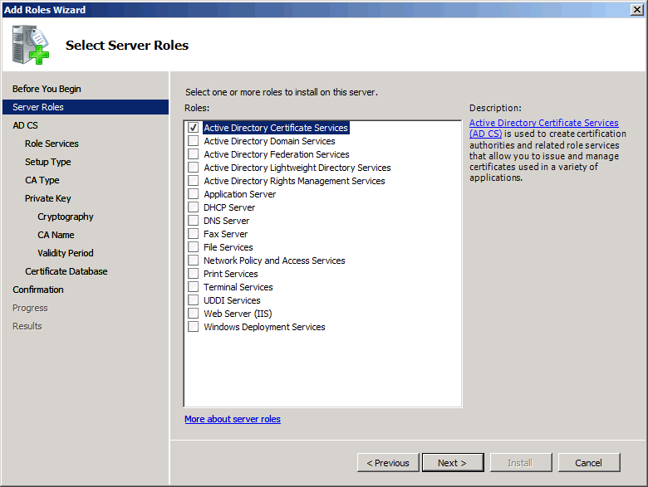

5. Click Next, and then click Next again.
6. In the Select Role Services dialog box, under Role services, select the Certification Authority Web Enrollment check box.
7. In the Add Roles Wizard dialog box, click Add Required Role Services.
Figure 5. Add Roles Wizard dialog box.
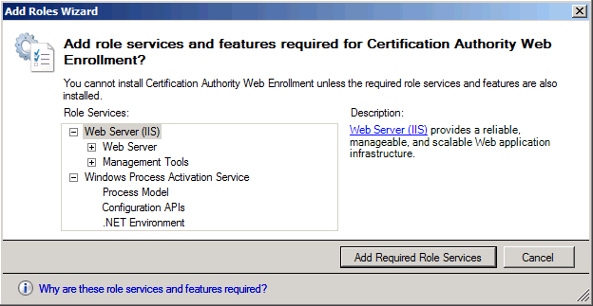

8. Click Next.
9. Click Standalone, and then click Next.
10. Click Root CA (recommended), and then click Next.
11. Click Create a new private key, and then click Next.
12. Click Next to accept the default cryptographic settings.
13. In the Configure CA Name dialog box, click Next to accept the default CA name.
Figure 6. Configure CA Name dialog box.
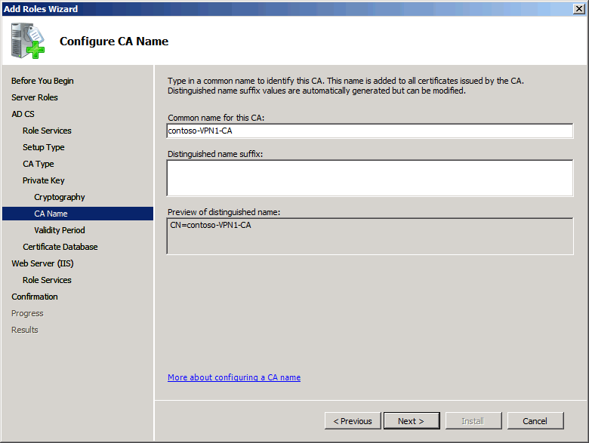

14. Click Next repeatedly to accept default settings.
15. In the Confirm Installation Selections dialog box, click Install. The installation might take several minutes.
16. In the Installation Results dialog box, click Close.

Create and install the Server Authentication certificate
The Server Authentication certificate is used by CLIENT1 to authenticate VPN1. Before installing the certificate, you must configure Internet Explorer to allow certificate publishing.
Configure Internet Explorer
1. On VPN1, click Start, right-click Internet Explorer, and then click Run as administrator.
2. If a phishing filter alert appears, click Turn off automatic Phishing Filter, and then click OK.
3. Click the Tools menu, and then click Internet Options.
4. In the Internet Options dialog box, click the Security tab.
5. Under Select a zone to view or change security settings, click Local intranet.
6. Change the security level for Local intranet from Medium-low to Low, and then click OK.
Note
In a real-world scenario, you should configure individual ActiveX® control settings by using Custom level rather than lowering the security level.
Figure 7. Internet Options dialog box.
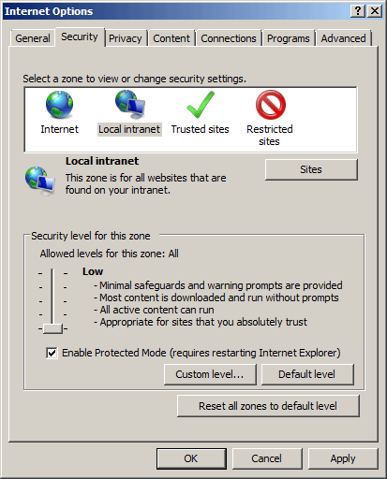

Use Internet Explorer to request a Server Authentication certificate.
Request a Server Authentication certificate
1. On VPN1, in the Internet Explorer Address bar, type http://localhost/certsrv, and then press ENTER.
2. Under Select a task, click Request a certificate.
3. Under Request a Certificate, click advanced certificate request.
4. Under Advanced Certificate Request, click Create and submit a request to this CA.
5. Click Yes to allow the ActiveX control.
Figure 8. Advanced Certificate Request page.
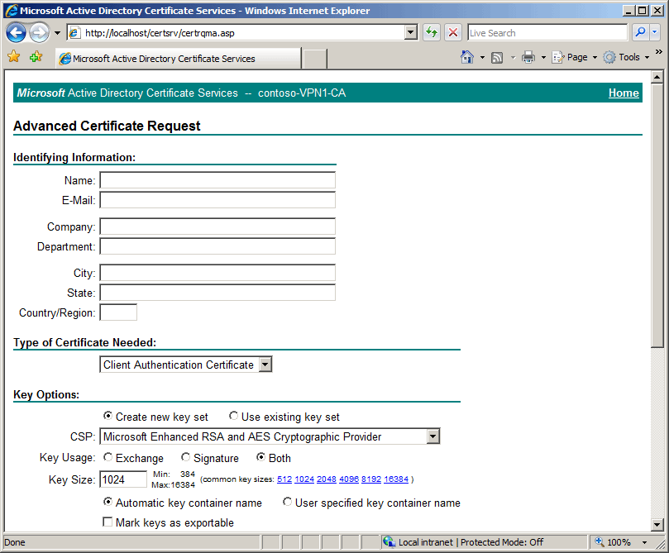

6. Under Identifying Information, in the Name field, type vpn1.contoso.com, and in the Country/Region field, type US.
Note
The name is the certificate subject name and must be the same as the Internet address used in the SSTP connection settings configured later in this document.
7. Under Type of Certificate Needed, select Server Authentication Certificate.
8. Under Key Options, select the Mark keys as exportable check box, and then click Submit.
9. Click Yes in the confirmation dialog box.
The Server Authentication certificate is now pending. It must be issued before it can be installed.
Issue and install the Server Authentication certificate
1. On VPN1, click Start, and then click Run.
2. In Open, type mmc, and then click OK.
3. In the Console1 snap-in, click File, and then click Add/Remove Snap-in.
4. Under Available snap-ins, click Certification Authority, then click Add.
5. Click Finish to accept the default setting of Local computer.
6. Click OK to close the Add or Remove Snap-ins dialog box.
7. In the newly created MMC console, in the left pane, double-click Certification Authority (Local).
8. Double-click contoso-VPN1-CA, and then click Pending Requests.
Figure 9. Certification Authority console.
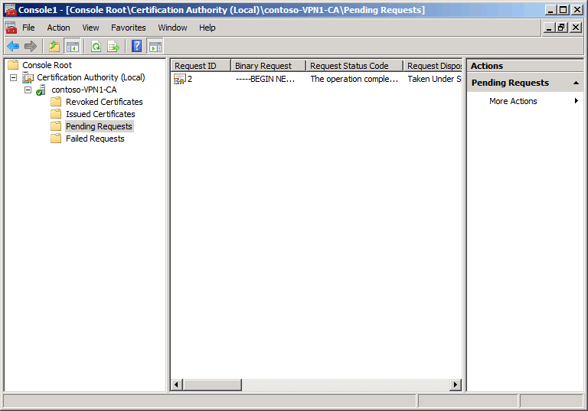

9. In the middle pane, right-click the pending request, point to All Tasks, and then click Issue.
10. In Internet Explorer, in the Certificate Pending page, click Home. If this page is not visible, browse to http://localhost/certsrv.
11. Under Select a task, click View the status of a pending certificate request.
12. Under View the Status of a Pending Certificate Request, select the just-issued certificate.
13. Click Yes to allow the ActiveX control.
14. Under Certificate Issued, click Install this certificate.
15. Click Yes in the confirmation dialog box.
Move the installed certificate from the default store location.
Move the certificate
1. On VPN1, in the previously created MMC console, click File, and then click Add/Remove Snap-in.
2. Under Available snap-ins, click Certificates, and then click Add.
Figure 10. Certificates snap-in dialog box.
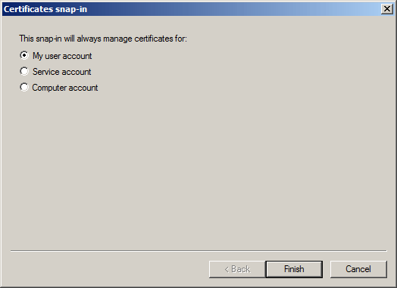

3. Click Finish to accept the default setting of My user account.
4. Click Add, click Computer account, and then click Next.
5. In the Select Computer dialog box, click Finish to accept the default setting of Local computer.
6. Click OK to close the Add or Remove Snap-ins dialog box.
7. In the console tree pane, double-click Certificates - Current User, double-click Personal, and then click Certificates.
8. In the middle view pane, right-click the vpn1.contoso.com certificate, point to All Tasks, and then click Export.
9. In the Welcome page, click Next.
10. Click Yes, export the private key, and then click Next.
11. Click Next to accept the default file format.
12. Type P@ssword in both text boxes, and then click Next.
13. In the File to Export page, click Browse.
14. In the File name text box, type vpn1cert, and then click Browse Folders.
15. Under Favorite Links, click Desktop, and then click Save to save the certificate to the desktop.
16. In the File to Export page, click Next.
17. Click Finish to close the Certificate Export Wizard, and then click OK in the confirmation dialog box.
18. In the console tree pane, double-click Certificates (Local Computer), and then double-click Personal.
19. Click Certificates, and then right-click Certificates, point to All Tasks, and then click Import.
20. In the Welcome page, click Next.
21. In the File to Import page, click Browse.
22. Under Favorite Links, click Desktop, and from the drop-down list, select Personal Information Exchange for the file type.
Figure 11. Certificate Import Wizard.
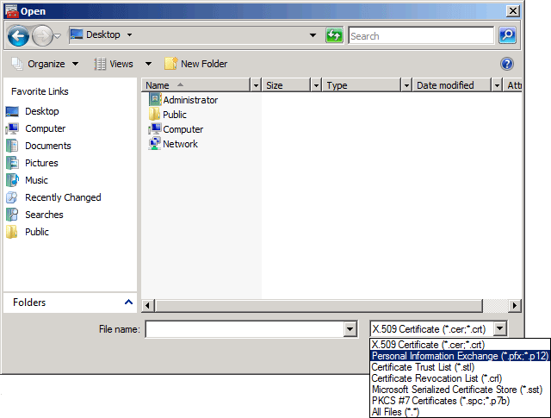

23. In the middle view pane, double-click vpn1cert.
24. In the File to Import page, click Next.
25. In the Password text box, type P@ssword, and then click Next.
26. In the Certificate Store page, click Next to accept the Personal store location.
27. Click Finish to close the Import Export Wizard, and then click OK in the confirmation dialog box.
Figure 12. Location of Server Authentication certificate.
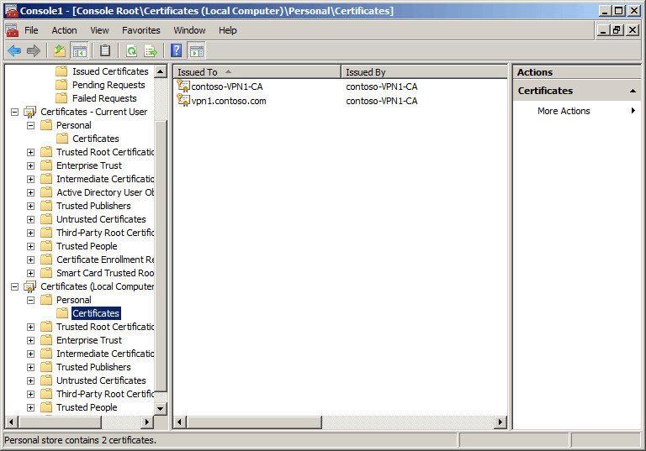

Important
If the procedures in this document are not followed in the order presented, the presence of an all purpose certificate (contoso-VPN1-CA) could create issues. Delete the contoso-VPN1-CA certificate in the Local Computer store to ensure the SSTP listener binds to the server authentication certificate (vpn1.contoso.com).
Delete the all purpose certificate
1. In the middle view pane, double-click Certificates, right-click contoso-VPN1-CA, and then click Delete.
2. Click Yes in the confirmation dialog box.

Install Routing and Remote Access
Configure VPN1 with Routing and Remote Access to function as a VPN server.
Install VPN and certificate services roles
1. On VPN1, in the Initial Configuration Tasks window, under Customize This Server, click Add roles.
Note If the Initial Configuration Tasks window is not already open, you can open it by clicking Start, clicking Run, typing oobe in the text box, and then clicking OK.
2. In the Add Roles Wizard dialog box, in Before You Begin, click Next.
3. Select the Network Policy and Access Services check box, click Next, and then click Next again.
4. In the Select Role Services dialog box, under Role services, select the Routing and Remote Access Services check box.
5. Click Next, and then click Install.
6. In the Installation Results dialog box, click Close.

Configure Routing and Remote Access
Configure VPN1 to be a VPN server providing remote access for Internet-based VPN clients.
Configure VPN1 to be a VPN server
1. On VPN1, click Start, point to Administrative Tools, and then click Routing and Remote Access.
2. In the Routing and Remote Access console tree, right-click VPN1, and then click Configure and Enable Routing and Remote Access.
3. In the Welcome to the Routing and Remote Access Server Setup Wizard page, click Next.
4. In the Configuration page, click Next to accept the default setting of Remote access (dial-up or VPN).
5. In the Remote Access page, click VPN, and then click Next.
6. In the VPN Connection page, under Network interfaces, click Public. This is the interface that will connect VPN1 to the Internet.
7. Click Enable security on the selected interface by setting up static packet filters to clear this setting, and then click Next.
Note
Normally, you would leave security enabled on the public interface. For the purposes of testing lab connectivity, you should disable it.
8. Click From a specified range of addresses, and then click Next.
9. Click New, type 192.168.0.200 for the Start IP address, type 192.168.0.210 for the End IP address, click OK, and then click Next.
10. Click Next to accept the default setting, which means VPN1 will not work with a RADIUS server. In this scenario, Routing and Remote Access Server will use Windows Authentication.
11. In the Completing the Routing and Remote Access Server Setup Wizard page, click Finish.
12. If the dialog box that describes the need to add this computer to the remote access server list appears, click OK.
13. In the dialog box that describes the need to configure the DHCP Relay Agent, click OK.
14. Close the Routing and Remote Access snap-in.

Configuring CLIENT1
CLIENT1 is a computer running Windows Vista with SP1 that functions as a remote access VPN client for the Contoso.com domain.
CLIENT1 configuration consists of the following steps:
• Install the operating system.
• Configure TCP/IP.
The following sections explain these steps in detail.

Install the operating system
To install Windows Vista with SP1 on CLIENT1:
Install Windows Vista SP1
1. On CLIENT1, start your computer by using the Windows Vista with SP1 product disc. Follow the instructions that appear on your screen.
2. When prompted for the installation type, choose Custom.
3. When prompted for the user name, type user1.
4. When prompted for the computer name, type CLIENT1.
5. When prompted for the computer location, choose Home.

Configure TCP/IP
Configure TCP/IP properties so that CLIENT1 has a static IP address of 131.107.0.3 for the public (Internet) connection.
Configure TCP/IP properties
1. On CLIENT1, click Start, and then click Control Panel.
2. Click Network and Internet, click Network and Sharing Center, and then click Manage network connections.
3. Right-click Local Area Connection, and then click Properties. If a dialog box is displayed that requests permissions to perform this operation, click Continue.
4. In the Local Area Connection Properties dialog box, click Internet Protocol Version 4 (TCP/IPv4), and then click Properties.
5. Click Use the following IP address. In IP address, type 131.107.0.3 for the IP address, and type 255.255.0.0 for the subnet mask.
6. Click OK, and then click Close.
Configure the hosts file to have a record for VPN1. This simulates a real-world scenario in which the corporate VPN server would have a publicly resolvable host name.
Configure the hosts file
1. On CLIENT1, click Start, click All Programs, click Accessories, right-click Command Prompt, and then click Run as administrator.
2. In the User Account Control dialog box, click Continue.
3. In the command window, type the following and then press ENTER:
notepad %windir%\system32\drivers\etc\hosts
4. Add the following text in a new line at the end of the document:
131.107.0.2 vpn1.contoso.com
5. Save and close the hosts file.
Run the ping command from CLIENT1 to confirm that network communication between CLIENT1 and VPN1 works.
Use the ping command to check network connectivity
1. On VPN1, click Start, point to Administrative Tools, and then click Windows Firewall with Advanced Security.
2. In the console tree, click Inbound Rules.
Figure 13. Windows Firewall with Advanced Security snap-in.
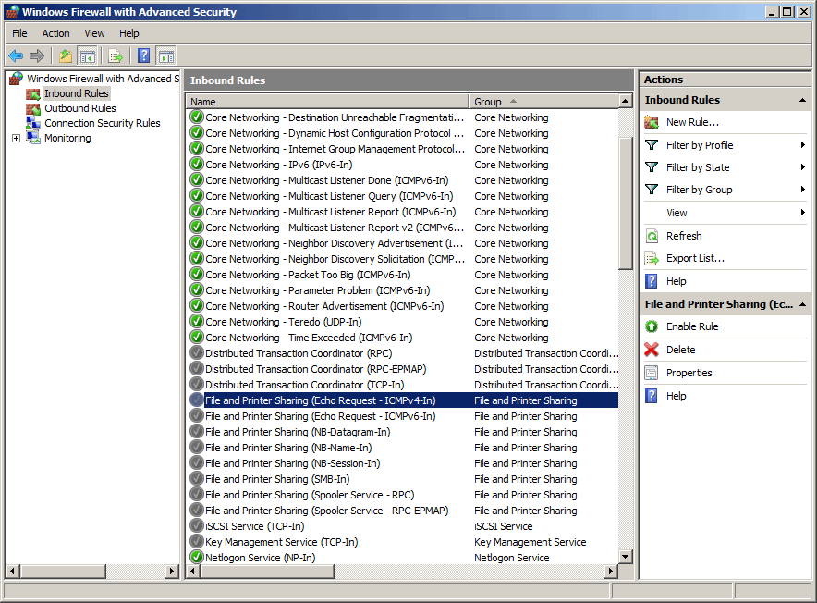

3. In the details pane, scroll down and double-click File and Printer Sharing (Echo Request - ICMPv4-In) for the Public profile. Verify that this rule is enabled.
Figure 14. File and Printer Sharing (Echo Request - ICMPv4-In) Properties dialog box.
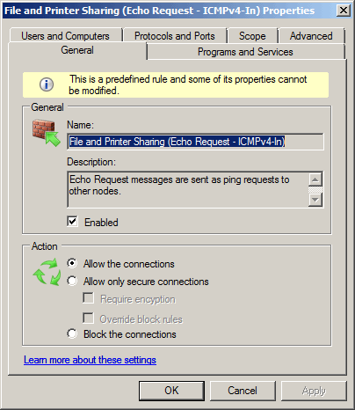

4. Under General, select the Enabled check box, and then click OK.
5. On CLIENT1, in the command window, type ping vpn1.contoso.com, and then press ENTER.
6. Verify that you can successfully ping VPN1.
For the purpose of this test lab, this connection signifies that the remote user can connect to the office VPN server over the public Internet.
7. Close the command window.

Simulating a PPTP-based connection failure
Now that the preceding steps have been completed, the lab infrastructure is in place. This section covers how to configure your lab setup so that PPTP-based VPN connections will fail. This simulates a real-world scenario in which the remote access server is behind a firewall that blocks PPTP connections. This lab will use Windows Firewall with Advanced Security on VPN1 to serve as the perimeter firewall.

Configure PPTP-based VPN connection
Create a PPTP connection.
Configure PPTP-based VPN connection
1. On CLIENT1, click Start, and then click Control Panel.
2. Click Network and Internet, click Network and Sharing Center, and then click Set up a connection or network.
Figure 15. Set up a connection or network dialog box.
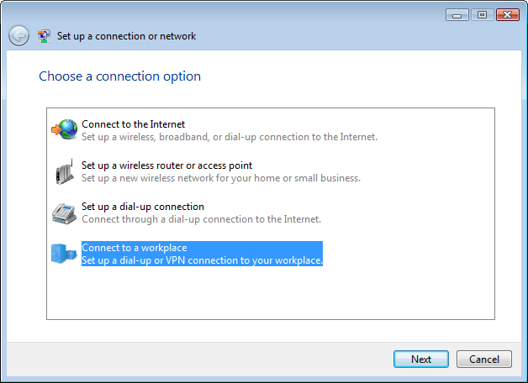

3. Click Connect to a workplace, and then click Next.
4. Click Use my Internet connection (VPN).
5. Click I'll set up an Internet connection later.
6. In Internet address, type vpn1.contoso.com, and then click Next.
Note
The Internet address must be the same as the subject name previously configured in this document. This requirement is for the SSTP connection used later in this document.
7. In the Type your user name and password dialog box, type the following information:
a. In User name, type user1.
b. In Password, type P@ssword.
c. Click Remember this password.
d. In Domain, type contoso.
8. Click Create, and then click Close.

Test PPTP-based connection
Test the PPTP connection. You should be able to successfully connect to VPN1 by using the PPTP-based VPN connection created on CLIENT1.
Test PPTP-based connection
1. On CLIENT1, in Network and Sharing Center, click Manage network connections.
2. Double-click VPN Connection, and then click Connect.
Figure 16. VPN Connection dialog box.
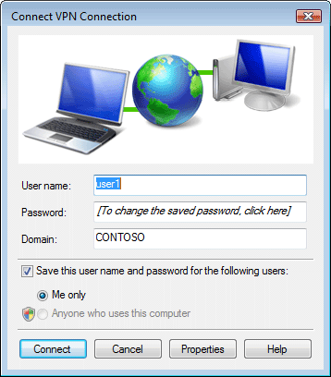

3. Verify that the connection was completed successfully by right-clicking VPN Connection, and then clicking Status. The Media State should be "Connected."
4. In the VPN Connection Status dialog box, click Disconnect.

Configure Windows Firewall with Advanced Security
PPTP traffic consists of traffic over TCP port 1723 for tunnel maintenance and traffic over IP protocol 47 for Generic Routing Encapsulation (GRE) for tunneling data. Configure Windows Firewall with Advanced Security to block inbound GRE traffic to VPN1. This simulates a remote access server behind a firewall that blocks PPTP connections.
Configure Windows Firewall with Advanced Security to block PPTP-based connections
1. On VPN1, click Start, point to Administrative Tools, and then click Windows Firewall with Advanced Security.
2. In the console tree, click Inbound Rules.
3. In the details pane, scroll down and double-click Routing and Remote Access (GRE-In).
4. Under Action, select Block the connections, and then click OK.
Figure 17. Routing and Remote Access (GRE-In) Properties dialog box.
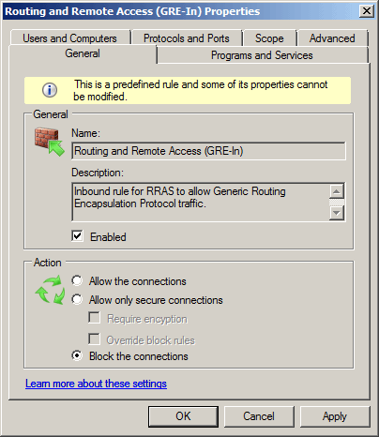

Test PPTP-based connection
Confirm that a PPTP-based connection to VPN1 is now blocked.
Test PPTP-based connection
1. On CLIENT1, in Network and Sharing Center, click Manage network connections.
2. Double-click VPN Connection, and then click Connect.
3. Verify that the connection was not completed. You should see a dialog box similar to the following:
Figure 18. PPTP-based VPN connection fails.
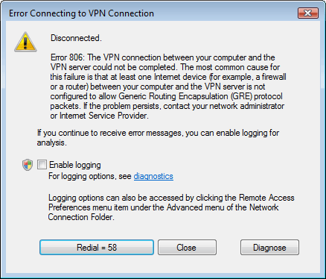

4. Click Close.

Configuring an SSTP-based connection
A VPN client using an SSTP connection must install the root CA certificate of the VPN server's computer certificate. During the SSL authentication phase, the VPN client validates the Server Authentication certificate using the certificate installed on the client.

Obtain a trusted root CA certificate
The root certificate can be obtained through auto-enrollment, if the client is joined to an Active Directory domain, or through Web enrollment from the CA's certificate-issuing Web site. In this scenario, CLIENT1 will obtain the root CA certificate from VPN1 by using Web enrollment.
Obtain a computer certificate from VPN1
1. On CLIENT1, click Start, and then click Internet Explorer.
2. In Internet Explorer, clear the URL and type http://vpn1.contoso.com/certsrv, and then press ENTER.
3. If a phishing filter alert appears, click Turn off automatic Phishing Filter, and then click OK.
4. On the Welcome page, under Select a task, click Download a CA certificate, certificate chain, or CRL.
5. If you receive an alert about the Information Bar, click Close.
6. Click Download CA certificate.
7. In the File Download dialog box, click Open.
Figure 19. File Download dialog box for the security certificate.
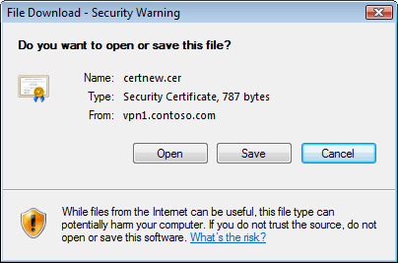

8. In the security alert dialog box, click Allow.
9. Click Install Certificate.
Figure 20. Certificate dialog box.
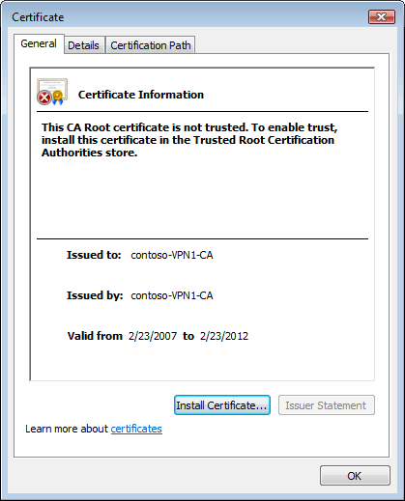

10. In the Certificate Import Wizard, click Next.
11. In the Certificate Store dialog box, click Next to accept the default automatic store location.
12. Click Finish.
13. In the confirmation dialog box, click OK.
14. Click OK to close the Certificate dialog box.
Now that the computer certificate has been installed, it must be moved to the correct store. The default automatic location for the installed certificate is in the Current User, Intermediate Certification Authority store. The certificate must be moved to the Local Computer, Trusted Root Certification Authority store on CLIENT1. Begin by configuring an MMC with user and computer certificate snap-ins.
Configure an MMC
1. On CLIENT1, click Start, click All Programs, click Accessories, and then click Run.
2. In Open, type mmc, and then click OK.
3. In the User Account Control dialog box, click Continue.
4. In the Console1 snap-in, click File, and then click Add/Remove Snap-in.
5. Under Available snap-ins, click Certificates, and then click Add.
6. Click Finish to accept the default setting of My user account.
7. Click Add, click Computer account, and then click Next.
8. In the Select Computer dialog box, click Finish to accept the default setting of Local computer.
9. Click OK to close the Add or Remove Snap-ins dialog box.
Move the installed certificate from the default store location. Because the certificate does not involve private key binding, you can simply copy and paste the certificate to the new certificate store.
Move the certificate
1. On CLIENT1, in the newly created MMC, in the console tree pane, double-click Certificates - Current User, double-click Intermediate Certification Authorities, and then click Certificates.
2. In the middle pane, right-click the contoso-VPN1-CA certificate, and then click Copy.
3. In the console tree pane, double-click Certificates (Local Computer), double-click Trusted Root Certification Authorities, and then click Certificates.
4. In the middle pane, right-click, and then click Paste.
5. Refresh the view to verify that the certificate has been added to this store.
Figure 21. New location for downloaded certificate.
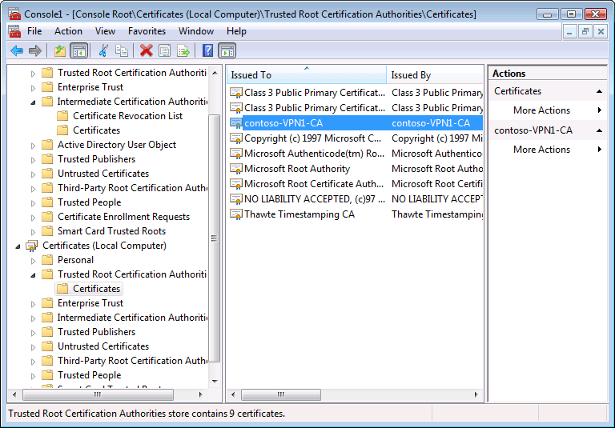

Configure and test an SSTP-based VPN connection
Now that the root CA certificate of the VPN server's computer certificate is in the Trusted Root Certification Authorities certificate store on CLIENT1, configure and test an SSTP connection.
Configure and test an SSTP connection
1. On CLIENT1, in Network and Sharing Center, click Manage network connections.
2. Double-click VPN Connection, and then click Properties.
3. Click the Networking tab.
4. From the Type of VPN drop-down list, select Secure Socket Tunneling Protocol (SSTP), and then click OK.
Figure 22. VPN Connection Properties dialog box.
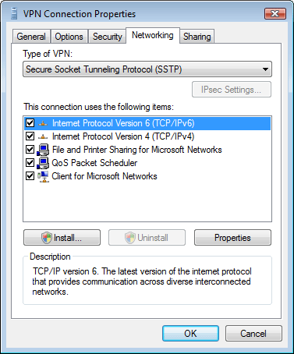

5. In the Connect VPN Connection dialog box, click Connect.
CLIENT1 should successfully connect to VPN1 using the SSTP connection. Verify that you can access the corporate file server from the remote location.
6. Click Start, click All Programs, click Accessories, and then click Run.
7. In Open, type \\dc1.contoso.com\corpdata, and then click OK.
8. Double-click VPNTest to open it, add some text, and then save the file.
9. Close VPNTest.

Additional Resources
• Screencast: Deploying SSTP Remote Access (http://go.microsoft.com/fwlink/?LinkId=102605)
• Routing and Remote Access Blog (http://go.microsoft.com/fwlink/?LinkId=82954)
• New Networking Features in Windows Server 2008 and Windows Vista (http://go.microsoft.com/fwlink/?LinkId=71606)

